1 | Product name | Hexagonal Gabion Planter
2 | Short brief | Add a touch of sophistication and style to your outdoor space with our hexagonal gabion bed raised garden planter
3 | Product 3D view | 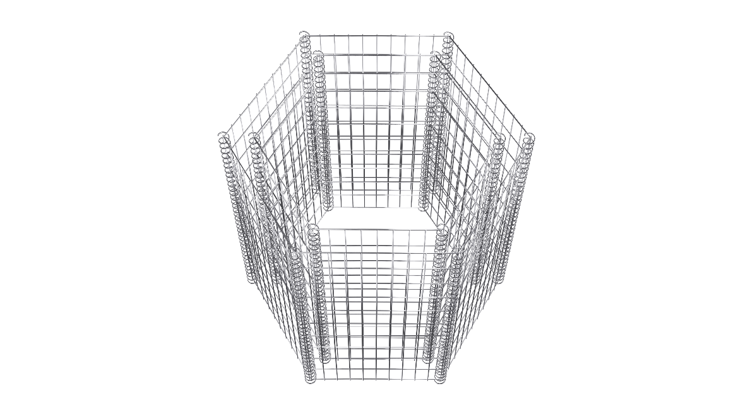
4 | Overview | This unique and eye-catching planter is perfect for growing a variety of plants, including flowers, vegetables, herbs, and shrubs. It can also be used to create a unique and stunning focal point in your garden or patio.  The hexagonal gabion bed raised garden planter is made of high-quality galvanized steel wire mesh, which is rust-resistant and weatherproof. This ensures that your planter will last for many years to come, even in the harshest weather conditions.  The hexagonal gabion bed raised garden planter is also very sturdy and durable, thanks to its sturdy construction and transverse and longitudinal wires welded at every intersection. This means that it can support a variety of plants and soil, without the risk of collapsing or warping.  In addition to its durability and functionality, the hexagonal gabion bed raised garden planter is also incredibly easy to assemble and maintain. Simply fill it with rocks, gravel, or other decorative materials to create a secure and stylish border for your garden bed  Article Number Outer Dimensions Inner Dimensions  GR1010 1000x900x500 800x700x500  GR1020 1000x900x1000 800x700x1000  GR1030 1600x1400x500 1400x1200x500  GR1040 1600x1400x1000 1400x1200x1000
5 | Features | - Multiple variants are available  - Wire diameter of 4 mm  - Mesh size 100x50mm  - Adds visual interest to your garden or patio  - Rust and corrosion resistant  - Better Life  - Galvanized  - Easy to assemble and maintain  - Versatile design can be used for a variety of purposes  - Custom finish coating available  - Multiple colors are available  - Stylish design  - 100% Tested
6 | Technical Specifications | Material Carbon steel wire  Wire Diameter 4.00mm  Wall Thickness 100mm  Mesh Size 100x50 mm  Spiral coil wire diameter 3mm  Spiral coil inner diameter 20 mm  Spiral Pitch 45mm  Load Capacity 1400 kg/m³  Assembly Required Yes  Rust proof Yes  Finishing Galvanized/ PVC coating  Color Silver
7 | Application | - Parks  - School  - Hotels  - Public Building  - Offices  - Outdoor spaces  - Residential  - Demarcation  - Sports Center
8 | Finishes | - Products are hot deep Galvanized to BS EN 1461 or Equivalent standards.  - Galvanized and Powder coated to BS EN 13438 or Equivalent standards.  - Only powder coating to non-standard  - Marine coat Coating for application near salt water
9 | STANDARD COLOURS | - Galvanized  - PVC Ral black 9005  - Custom colors and coating are available
10 | Installation | At Hitech Gabion, we provide premium gabion products tailored to your needs and offer comprehensive support for your project's success. While we don't directly offer installation services, our expert team is available to provide detailed instruction manuals and consultancy to guide you through the installation process. If you require additional installation support, we can connect you with trusted construction vendors. Your satisfaction and project success are our top priorities, and we're committed to helping you achieve outstanding results every step of the way.
11 | Downloads | - Installation manual  - Product data sheet  - Drawing PDF  - Tech specification MS word
12 | Approvals

