1 | Product name | Arched Gabion Raised Bed
2 | Short brief | Explore our Arched Gabion Planters, available in four variants, perfect for residential and commercial spaces. Elevate your garden decor with this eye-catching Gabion product, featuring dual partitions for both aesthetics and gardening purposes.
3 | Product 3D view | 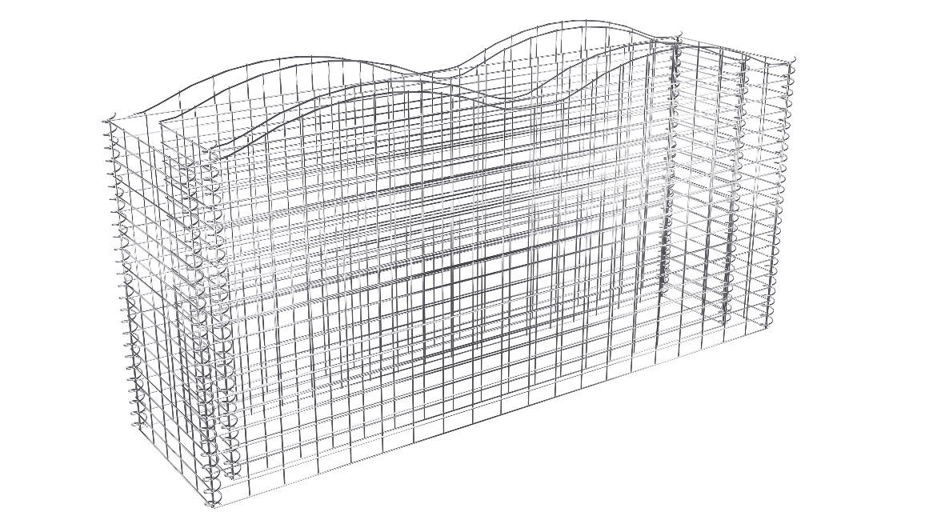
4 | Overview | Introducing our Arched Gabion Planters, a unique and versatile Gabion product designed to enhance both residential and commercial areas. With four variants to choose from, these eye-catching arches serve as stylish Gabion planters, featuring outer partitions for rocks or gravels and inner partitions for vibrant gardening. Crafted from robust 4.00mm diameter wire mesh, galvanized for rust and water resistance, these planters boast a mesh structure designed for a high load capacity of 1400 kg/m3. The waterproof and rust-resistant properties ensure a long-lasting outdoor presence, making them an ideal addition to your garden decor.  Variants Outer Dimension Inner dimension  GR1110 2000x500x1000 1800x300x1000  GR1120 2000x1000x1000 1800x800x1000  GR1130 4000x1000x1000 3800x800x1000  GR1140 6000x1000x1000 5800x800x1000
5 | Features | - Multiple variants are available  - Wire diameter of 4 mm  - Mesh size 100x50mm  - Adds visual interest to your garden or patio  - Rust and corrosion resistant  - Better Life  - Galvanized  - High Load Capacity (1400 kg/m3)  - Easy to assemble and maintain  - Versatile design can be used for a variety of purposes  - Custom finish coating available  - Multiple colors are available  - Stylish design  - 100% Tested
6 | Technical Specifications | Material Carbon steel wire  Wire Diameter 4.00mm  Wall Thickness 100mm  Mesh Size 100x50 mm  Spiral coil wire diameter 3mm  Spiral coil inner diameter 20 mm  Spiral Pitch 45mm  Load Capacity 1400 kg/m³  Assembly Required Yes  Rust proof Yes  Finishing Galvanized/ PVC coating  Color Silver
7 | Application | - Parks  - School  - Hotels  - Public Building  - Offices  - Outdoor spaces  - Residential  - Demarcation  - Sports Center
8 | Finishes | - Products are hot deep Galvanized to BS EN 1461 or Equivalent standards.  - Galvanized and Powder coated to BS EN 13438 or Equivalent standards.  - Only powder coating to non-standard  - Marine coat Coating for application near salt water
9 | STANDARD COLOURS | - Galvanized  - PVC Ral black 9005  - Custom colors and coating are available
10 | Installation | At Hitech Gabion, we provide premium gabion products tailored to your needs and offer comprehensive support for your project's success. While we don't directly offer installation services, our expert team is available to provide detailed instruction manuals and consultancy to guide you through the installation process. If you require additional installation support, we can connect you with trusted construction vendors. Your satisfaction and project success are our top priorities, and we're committed to helping you achieve outstanding results every step of the way.
11 | Downloads | - Installation manual  - Product data sheet  - Drawing PDF  - Tech specification MS word
12 | Approvals

